MEMORANDUM

DATE: October 16, 2017

TO: Betsy Schlobohm, J.D.

FROM: Alex Lundin

SUBJECT: Feasibility Report on Micro Services Architecture

**Industry Background**

Bank of America is ranked the 26th largest company on the Fortune 500 [1]. Bank of America developed it’s first mobile banking application in 2007 [2]. Bank of America is about to enter the realm of micro services architecture [3].

Bank of America continues to grow as a banking leader and they support many devices with their mobile banking application. Customers want to access their bank profile from a wide range of personal devices supplied by the tech industry. Bank of America has reached a turning point where it must invest in more cost effective software.

**Problem Statement**

Bank of America must become efficient and flexible as a tech company in the banking industry [3]. Bank of America has a history of Software that is outdated and expensive to maintain. In order to thrive as a business, they must transition to a more agile methodology with their Software applications.

**Options**

There are three options available. They are:

* Option 1: Stay Monolithic
* Option 2: Convert completely to Micro Services
* Option 3: Hybrid approach with both Monolithic and Micro Services

**Option Assessment**

*Option 1: Stay Monolithic.*

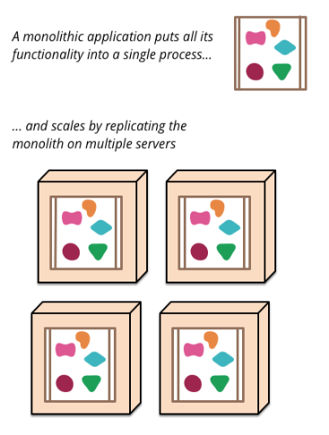A monolithic approach stems from the beginning of the computer age. Developers would write large applications that pulled from one code base. These systems happen to be bulky and expensive to maintain due to their size.

Monoliths put all their functionality into one place. Companies then must duplicate this large, cumbersome piece of Software on any new server that needs to use, even one tiny piece of the whole application. Figure 1 shows the distribution pattern for a large, single source application.

Fig. 1 [4]

*Option 2: Convert completely to Micro Services*

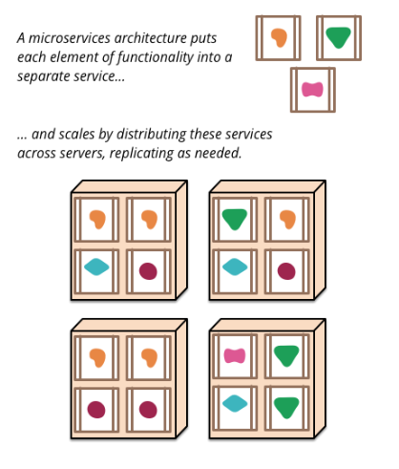Micro services architecture is a style that breaks up large applications into logical pieces. These pieces work together to solve tasks that the entire application is designed to handle as a whole. Figure 2 shows how the different shapes represent tiny pieces of a larger application.

The primary benefit of this style is the efficiency for devices. In some cases, you might only need a small part of the entire application. This is where the terms micro services come into play. The application is broken down into tiny services that

can be accessed as needed.

Fig. 2 [4]

*Option 3: Hybrid approach with both Monolithic and Micro Services*

Both architectural styles have their draw backs. Monolithic is slow and micro services is complicated. A blend of the two would yield the best results for a company that already exists in the market as a monolithic style.

Legacy code is any code that a company already has created and needs to maintain. Bank of America has plenty of legacy code that would require updating. This means switching immediately to a new style would cause some growing pains.

**Recommendations**

I would recommend the following:

* Staying Monolithic is not viable, a transition must be made.
* Bank of America must assign a Software Team to find access points in the monolithic architecture immediately.
* This team can continue to develop new projects, in the micro services style.
* As the team grows, it can continue to rebuild the previous architecture into a entirely micro services oriented approach.

References

[1] Fortune. (2017). Bank of America Corp.. [online] Available at: http://fortune.com/fortune500/bank-of-america-corp/ [Accessed 16 Oct. 2017].

[2] The birth of mobile banking, [online], available at: https://about.bankofamerica.com/en-us/our-story/the-birth-of-mobile-banking.html#fbid=expitmOJ3fA [Accessed 16 Oct. 2017].

[3] Inside Bank of Americas Online Transformation, [online],

Available at: https://www.networkworld.com/article/3041009/data-center/inside-bank-of-america-s-it-transformation.html [Accessed 16 Oct. 2017].

[4] Why Companies Adopt Microservices And How They Succeed , [online],

Available at:

https://medium.com/microhq/why-companies-adopt-microservices-and-how-they-succeed-2ad32f39c65a [Accessed 16 Oct. 2017].

[5] Our History and Heritage, [online], Available at:

https://about.bankofamerica.com/en-us/who-we-are/our-history-and-heritage.html#fbid=expitmOJ3fA/hashlink=%2523the-rise-of-industry[Accessed 16 Oct. 2017].

[6] Authors, “Title”, volumn number, [Online], available at: http:// [Accessed date]